for deriving the space complexity consider the worst case
eg for frequency of element problem :
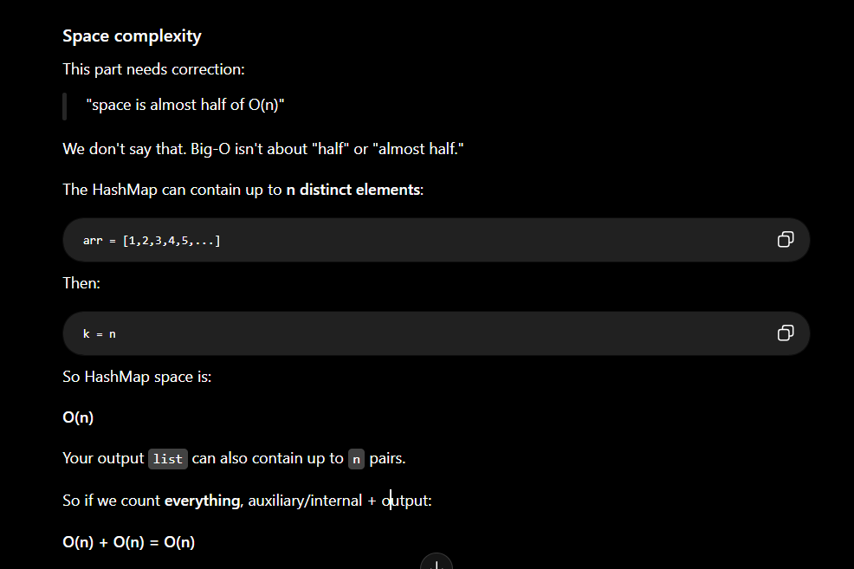
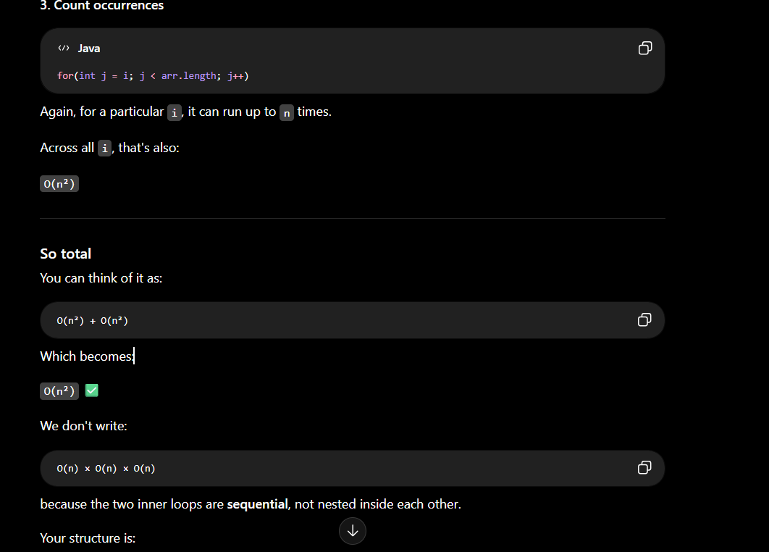
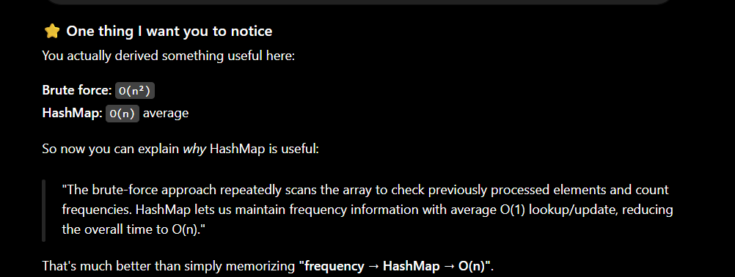

If the frequency used in the hashmap becomes zero ..remove the key .

- Hashmap don’t give element in order

